**Superintendent’s Corner**

Gary S. Reese, Ed.D.

Interim Superintendent

February 28, 2016

**Budget Meetings**

The budget workshops have been scheduled for the development of the 2016-2017 school budget.  All meetings will start at 6:00 pm and be held in the Amesbury High School library.

**February 29 –    Budget Visioning**

During this evening, I will present some goals for the budget development process. There will also be an opportunity for the public to make some comments about items to consider as budget priorities. Questions such as, “What do you value about the Amesbury Public Schools?”  and "What areas do you feel should be addressed to continue to improve opportunities for our students?" will be the focus for this initial conversation.  By having this visioning session, it will give an opportunity for public comment and input BEFORE budgets are proposed and the administration will use information from the meeting to help finalize all budgets for the district.

**March 3 -       Middle School budget  High School budget**

**Innovation HS budget Athletics Budget**

**March 10 -     AES budget** **CES Budget**

**Curriculum Budget** **Employee Benefits**

**Health Insurance**

**March 15 -     SPED Technology**

**Central Office** **Maintenance**

**Revenue budget** **Fee conversation**

**March 16 -**      **Snow Date**(If any meetings need to be postponed due to inclement weather, the topics from that meeting will be discussed on this date).

**March 22** -         **Budget Hearing - Public Comment and Input on Proposed final budget**

**April 4 -              School Committee Vote on budget - at regular school committee meeting**

**Director of Student Services**

I am pleased to announce our two finalists for the Director of Student Services position beginning July 1, 2016. Kathryn Clark and Mary Anne Houde emerged as finalists from over 25 applicants. Ms. Clark is currently the regional director for Springboard Education in America. She has prior experience as a principal and in special education administration. Ms. Houde has worked for the past 16 years in the Wilmington Public Schools, first as a special education teacher, team chairperson and currently as the director of special education. Students, parents, staff and community members are invited to a forum on Tuesday, March 1st from 6:30 - 8:00 pm at the Amesbury High School in the library to meet the candidates and learn about their experiences and skills. The two candidates will then meet with the school committee members on Monday, March 7th.

**In our Schools This week…**

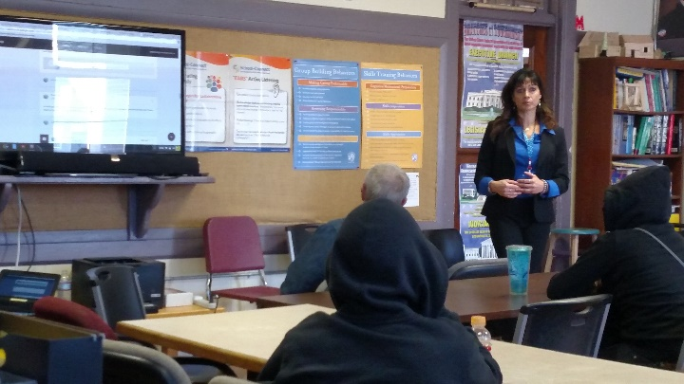***Amesbury Innovation High School – Rotary Luncheon:*** On Thursday, the Amesbury Innovation High School invited members of the Rotary Club for a luncheon at the school. The goal of this luncheon was to thank the members of the Rotary for the funding to purchase Chromebooks and to demonstrate how the teachers and students are using the Chromebooks in the classroom.

**Cashman Elementary School Immigration Dinner –** Thursday evening, fourth grade students at the Cashman School were treated to a special evening as a culmination of their studies around immigration. The students held a dinner where they brought samples of food from their heritage. The students were all very well behaved and well dressed. The dinner was served by staff members from the Cashman School. Following dinner, students had an opportunity to dance, songs that they had learned during music and physical education classes. This event is a great example of the type of skills that students learn that are critical to future success, but not measureable on standardized tests.

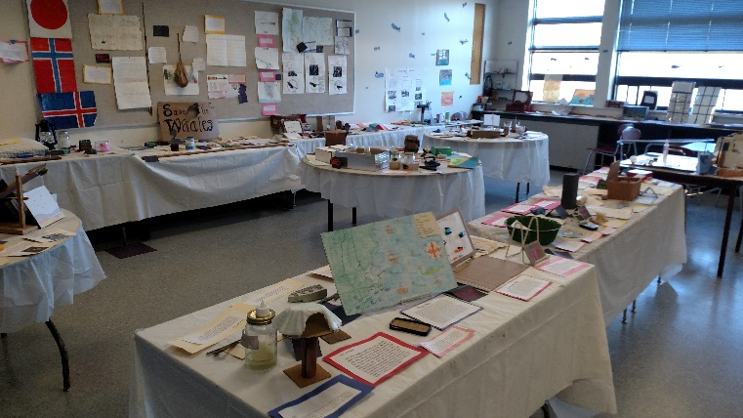**Amesbury Middle School 7th Grade Project –** During a visit on Friday to Amesbury Middle School, Principal Curry shared the products of a seventh grade project on the Whaling and Fishing Industry. The students selected topics of study that were of interest to them and developed projects that demonstrated their understanding of the essential question for the project – “How has the industry evolved over time?” All of the projects were displayed together in a ‘Whaling and Fishing Museum’. As part of this project, the students also had the chance to hear from fishermen from Gloucester.

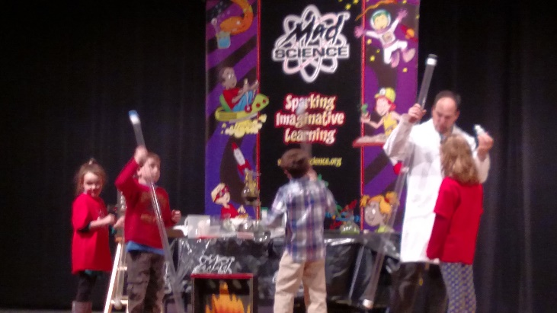**Elementary Science Fair –** Saturday, I had the pleasure of serving as a judge for the Elementary PTA Science Fair. I was very impressed with the range and quality of the projects, as well as the students’ ability to articulate their understanding of their projects, using appropriate vocabulary and identifying the scientific method. The students and families also were treated to a science show from the ‘Mad Scientist’.

Be well and have a great weekend!

Gary